**Finding Garments for the next Job**

As an assistant, your job is to support the operator by looking ahead and staging the next garments. As the operator, let the assistant know before your last two runs that you’ll need the garments brought over shortly!

They work from the top of the column to the bottom.

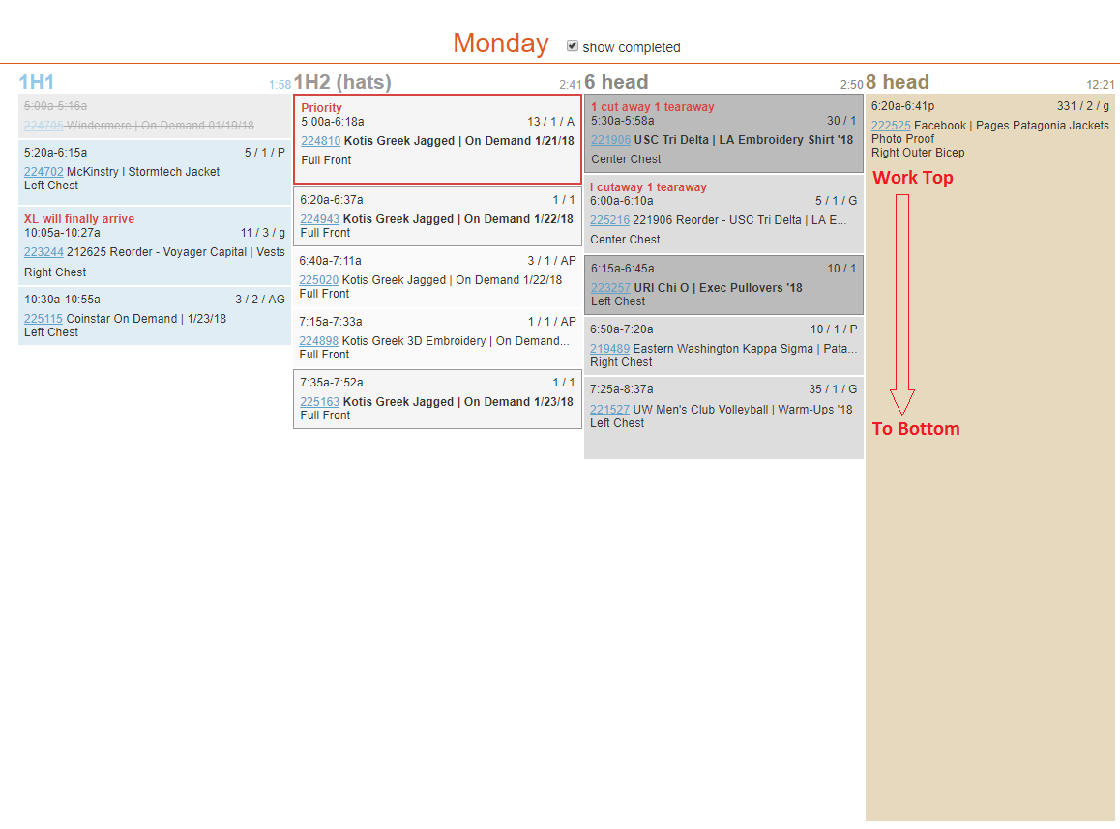

If the 6 head operator, has begun working on 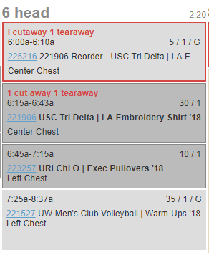

PO 221906 USC Tri Delta - you will want to look for the next jobs garments.

<~ PO 225216 Shows a “G” because they are not counted out. With further investigation, we see that they are arriving later today, so we will skip to the next job!

**<~ 223257 Uri Chi O Pullovers are counted out but not in embroidery so we need to go find them!**

<~ PO 221527 UW Men’s Club Shows a “G” because they are not counted out.

**Let’s focus on 223257 Uri Chi O Pullovers.**



They are showing counted out:

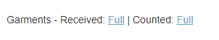

The garments are not in Embroidery, so they must be somewhere on the count out floor.

Start by looking on the rolly tables along the the bay doors.



The stack should have a printed PO on top.



If you are having a hard time finding it, it’s possible they are on the screen printing side.

If you don’t find it in the first 3 minutes, ask a member of the count out crew so they can locate it. We do not want you wasting time wandering around. If something is missing, slack the count out manager and the department’s manager that the garments are missing and move on to the next job.



Let’s go back to POs 225216 and 221527 which shows a “G”.

If it is delivered to the building, but not counted out it will look like this:

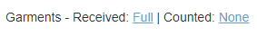

If it is not delivered yet, it will look like this:



**What does is mean when it says Partial?**

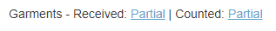

**Partial Garments** mean not all of the garments have arrived. If this is the case, we should hold off on decorating the PO until it is complete, unless the red text instructions read otherwise:

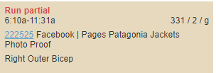

**Partial Counted** means not all the garments have been counted out. Slacking the count out manager and department manager will progress that so we can get started ASAP.

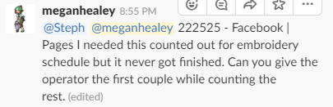

**Example 1:**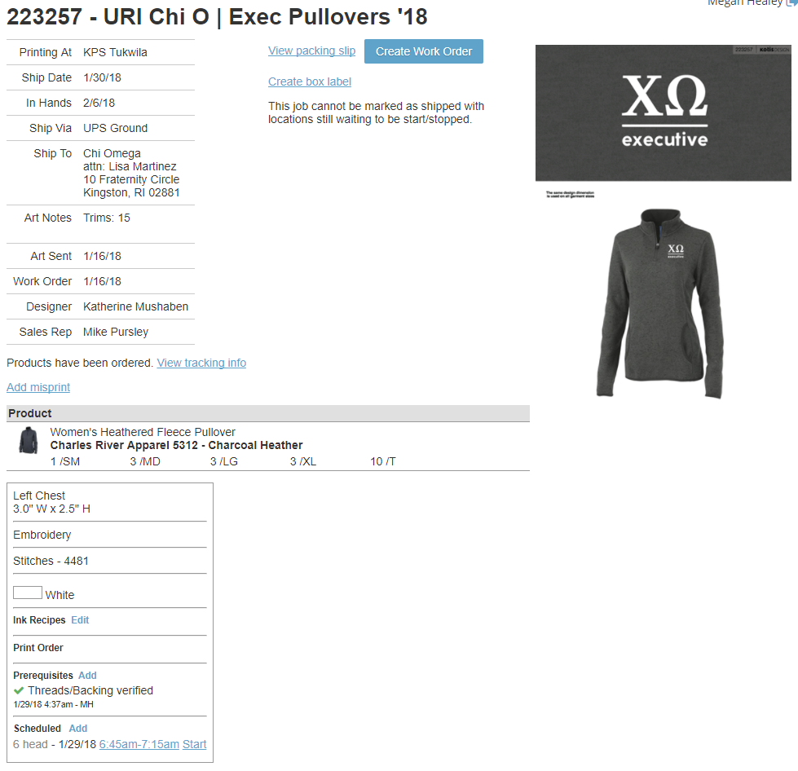



**Example 2:**

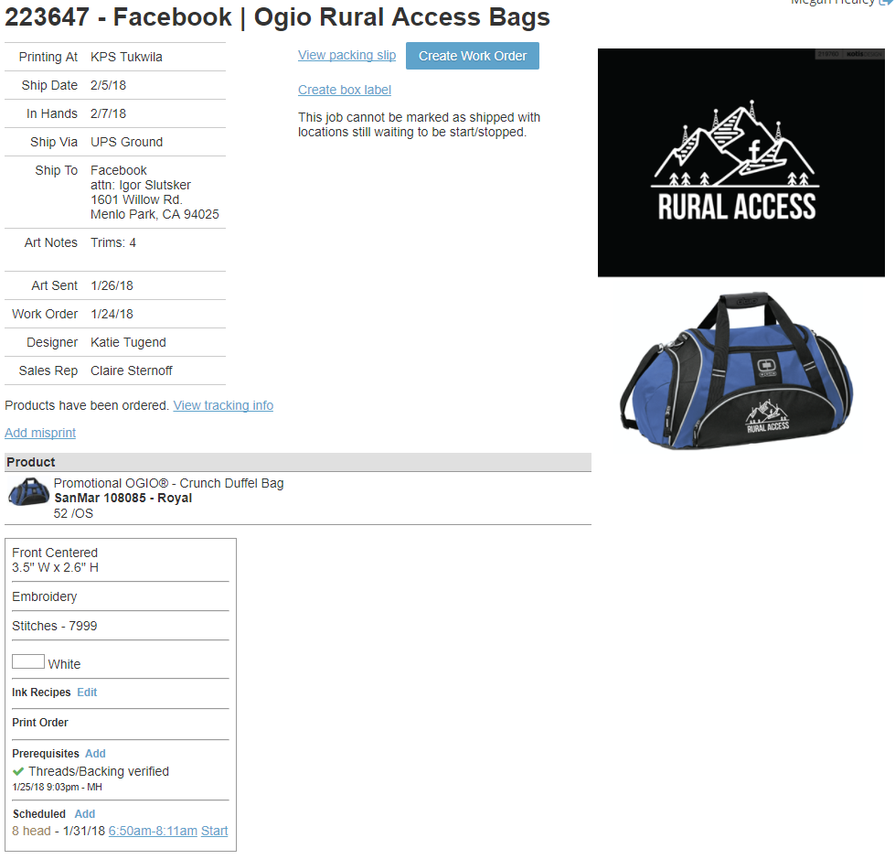



**Example 3:**



